DEPARTMENT OF BASIC SCIENCES AND ISLAMIAT
University of Engineering and Technology, Peshawar

Quiz No 01

Summer -2020
(Department of Computer System Engineering)

Question # 01

Find “b” so that the given function is harmonic
(a) 0 (b) 1 (c)  (d) None of these

Question # 02

All solutions of are
(a) 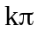 (b) 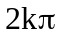 (c) 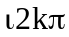 (d) None of these

Question # 03

Find the line integral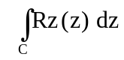 C: is the shortest path from t0
(a)  (b)  (c) 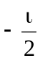 (d) None of these

